

**THE UNIVERSITY OF AZAD JAMMU KASHMIR MuZAFFARABAD**

**LAB TASK NO# 2**

**OPERATING SYSTEM**

**DEPARTMENT OF SOFTWARE ENGINEERING**

**SUBMITTED TO:** Engr. Sidra Rafiq

**SUBMITTED BY:** Asif Ullah

**SUBMITED ON:** 13/11/2024

**SEMESTER:** 3rd

**COURSE CODE:**

**ROLL NO# BS-2023-SE-38**

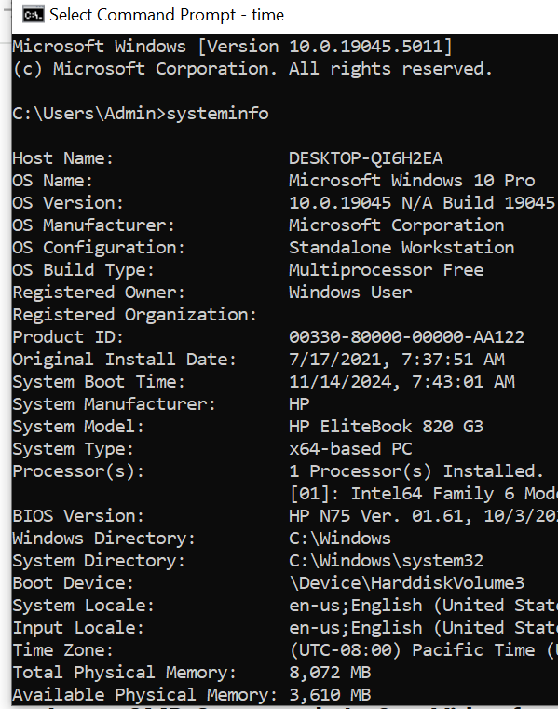

**Volume**

* In these we check that which drive are present;

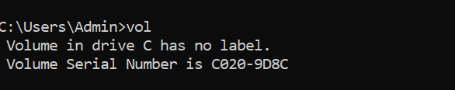

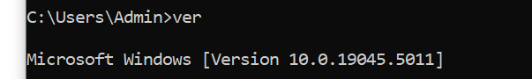

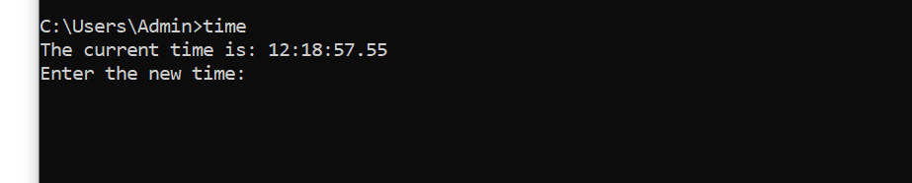**Time:**

**Date:**

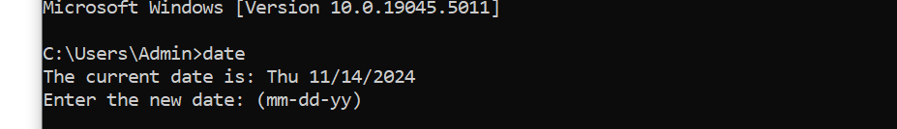

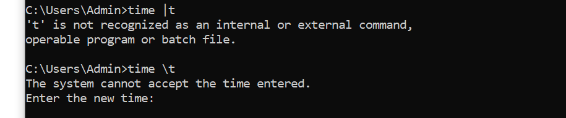**Current time:**

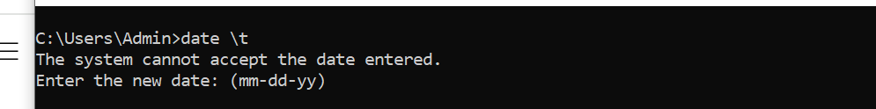**Current Date:**

**C drive to D drive:**

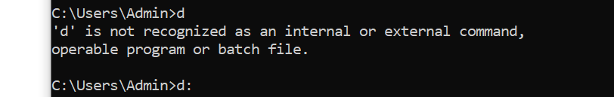

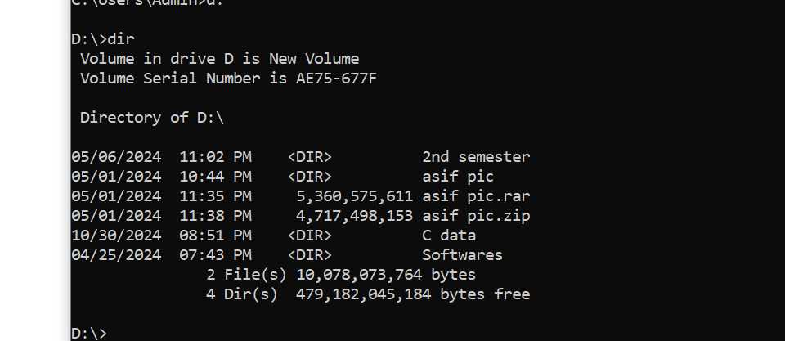 **Information about D drive:**

**2nd semester:**

* Information about the 2nd semester:

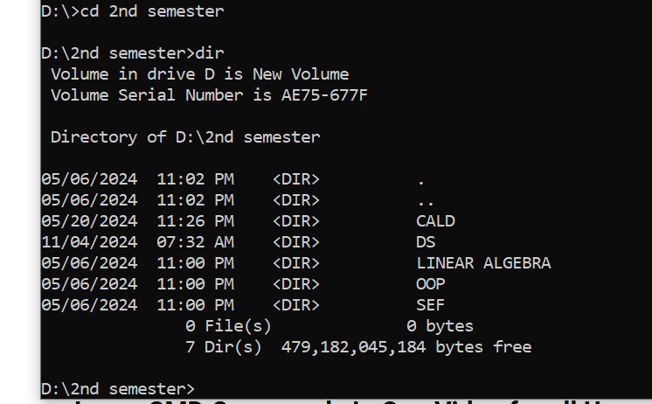

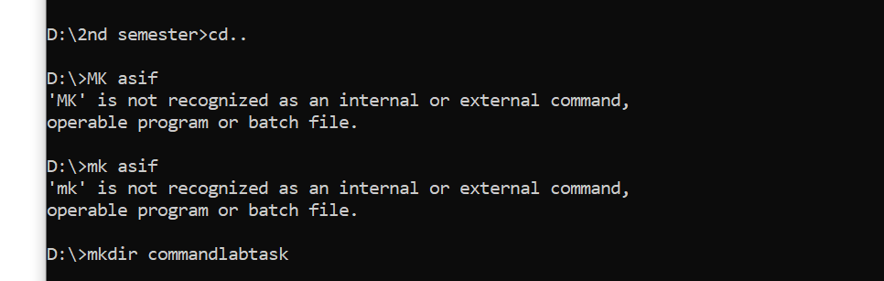**Asif command lab task:**

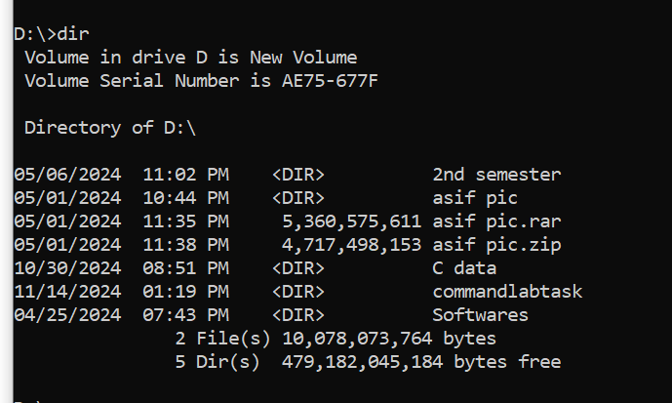 **How to see the folder that we create:**

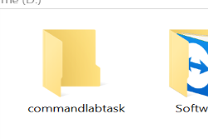

**Inside the folder**:

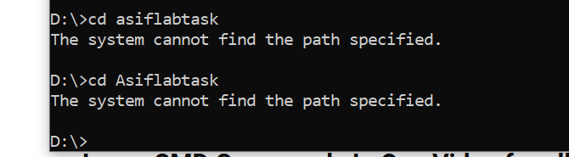

**Create new file in com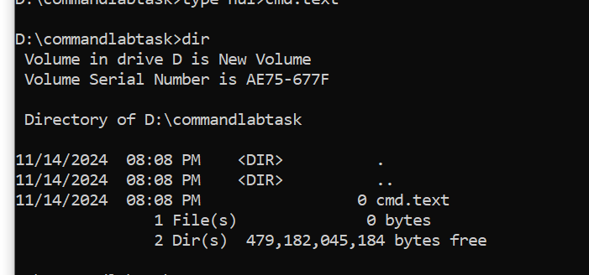mandlabtask:**

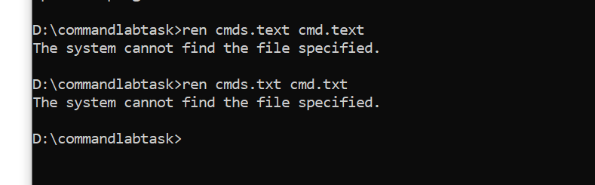**Rehname the file:**